

A Project Report On

**Placement portal**

**By**

**Harshith S**

**B.E**

**Batch:** 2021 – 5757

**Center: Bangalore- Palya**

Under the Guidance of,

**Jayant V.**

**Technical Trainer**

**EduBridge**

(School of coding)

## Introduction:

Placement Portal manages student information in the college with regard to placement. It improves existing system .It has the facility of maintaining the details of the student, thereby reducing the manual work. It will save time and energy which are spending in making reports and collecting data. Placement Management System can be accessed throughout the college with proper login provided. Our Project Include

**Modules:-**

* Admin Module
* User Module

I have developed this Application in **Java, JSP, Servlets, Hibernate and MySQL.** It’s a web-based projects so I have used **HTML, CSS, JavaScript and Bootstrap also**.

The main feature of the project is to make placement portal easier. You can access this website from anywhere and everywhere.

In Admin module, admin can add the job role and view user detail in the specific category. He can also view the total number of users at present in the website. And job role and user details also. Admin can only see the admin page and cart if he wants to order something.

In User module, user can access the website and apply job and shuffle by category. New user can register and login after that to portal. user can access to job they applied to the job role.

**Software Requirements:**

**Front end:** Java/J2EE technologies (Servlet, JSP), HTML, CSS, JavaScript, Bootstrap, Hibernate.

**Back end**: MySQL workbench 8.0.23CE.

**Middleware/Server:** Apache Tomcat. IDE: Eclipse IDE for Java EE Developers

**Browser:** Best result on Google Chrome

**Operating System:** Window 10.

**Data Dictionary**

MySQL

Create Database shopping;

• Set :

database.driver=com.mysql.jdbc.Driver

database.url=jdbc:mysql://localhost:3306/ shopping

database.user=root

database.password=harshith

Hibernate:

• Set : hibernate.dialect=org.hibernate.dialect.MySQLDialect

hibernate.show_sql=true

hibernate.format_sql=true

hibernate.hbm2ddl.auto=update

• Map Tables;

hibernate.mapping_class=Register

hibernate.mapping_class=Contact

hibernate.mapping_class=Payment

hibernate.mapping_class=Product

• Create Tables using this Annotations.

@Id

@Column

@Table

@GeneratedValue

# **Screenshots**

**User home page**



**Admin home page**



**Register Page:**

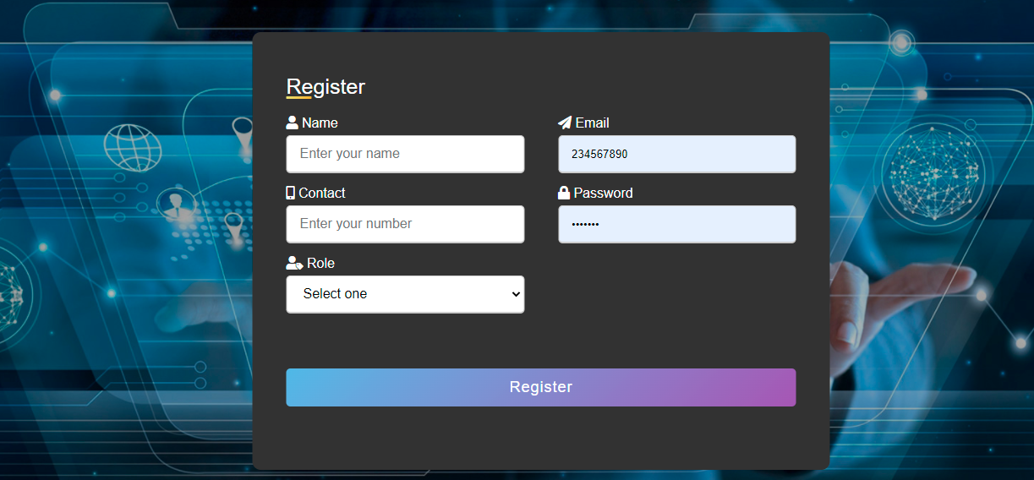

**Registered successfully**

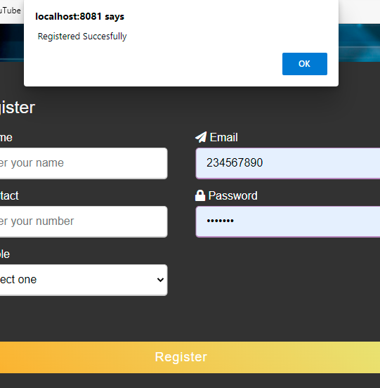

**Add job**

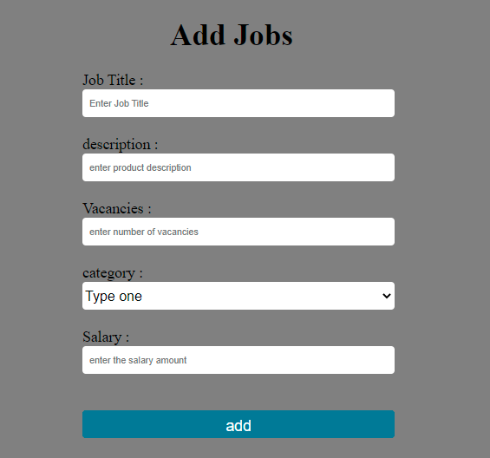

**View job**

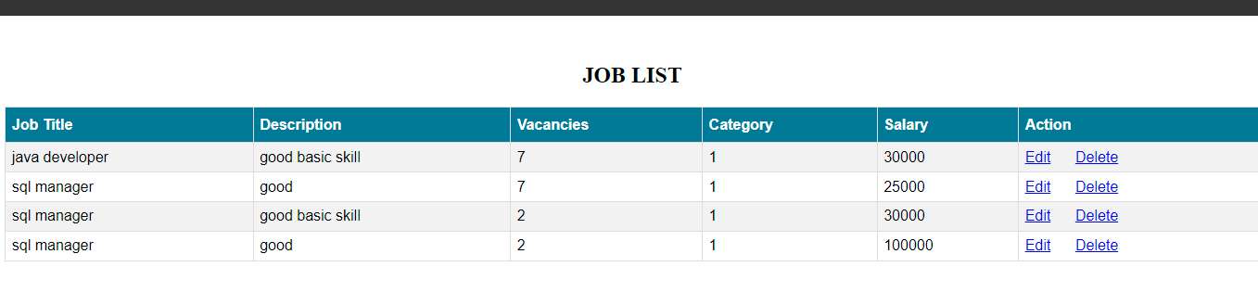

**User detail**

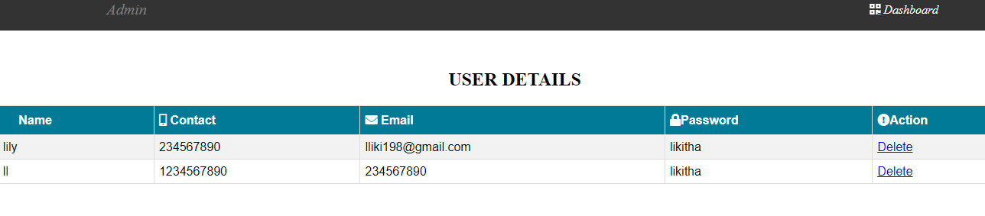

**Notification**

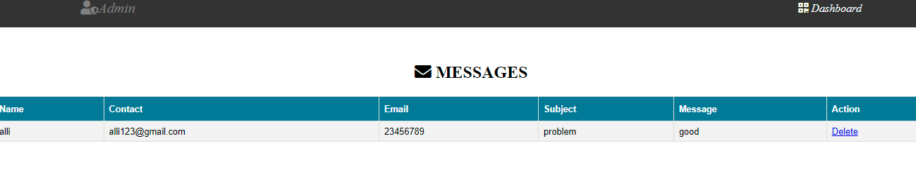

**Contact us**

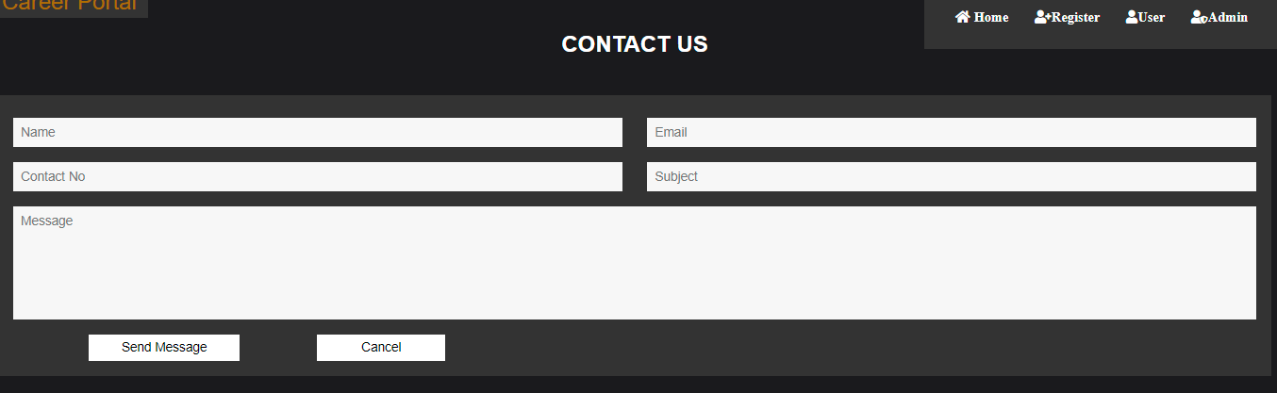

**About us**



**Thank you**